**1) What is an algorithm?**

**Answer:**

A step-by-step solution to a problem is called an algorithm.

**2) Explain need of an algorithm?**

**Answer:**

On a number of occasions, we humans need to do repetitive tasks. Manually performing these tasks will require a lot of man power and resources which is inefficient. To perform such tasks we take help from computers by writing computer programs which utilize algorithms to solve and provide a step-by-step solution to such problems.

**3) Write an algorithm to find average age of a group of 10 players?**

**Answer:**

1. Start
2. Initialize “Sum of ages”
3. Initialize “count=0”
4. Input “age”
5. Count = count + 1
6. Sum of ages = sum of ages + age
7. If “count ≤ 9”

[Go to line no.04]

Else  
[(sum of ages)/10=average age of players]

1. Print “Average age of players”
2. End

**4) Write algorithm to this problem:**

**Explain steps involve in drawing of a flowchart.**

**“****Ramshewak goes to market for buying some fruits and vegetables. He is having a currency of Rs 500 with him for marketing. From a shop he purchases 2.0 kg Apple priced Rs. 50.0 per kg, 1.5 kg Mango priced Rs.35.0 per kg, 2.5 kg Potato priced Rs.10.0 per kg, and 1.0 kg Tomato priced Rs.15 per kg. He gives the currency of Rs. 500 to the shopkeeper. Find out the amount shopkeeper will return to Ramshewak. And also tell the total item purchased.”**

**Explain steps involve in drawing of a flowchart.**

**Explain uses of Flowchart.**

**Answer:**

**Algor****ithm:**

1. Start
2. Go to Market
3. Input Total amount available (Total amount available = Rs.500/-)
4. Total Cost = 0
5. Count = 0
6. Input price of article
7. Total Cost = Total Cost + price of article
8. Count = count +1
9. While count ≤ Total no. of article (Goto step 7)
10. Print Amount left = Total amount – Total cost
11. Print “No. of articles purchased = count”

**Steps and thought process involved in drawing the following flowchart:**

The given problem requires the calculation of the amount left after shopping and the number of items bought by the customer.

(1) The first step will be to take in the input of the total amount from the user.

(2) After that a counter has been put into place so that the amount of all the articles can be summed together for the calculation of the total cost. The counter will also determine the number of items bought which will be equal to the number of times the loop ran.

(3) The loop will continue to add the price of each item into the total cost of all the previous items entered.

(4) When the prices of all the articles has been entered the user will instruct the program to calculate the total cost, the amount left as well as the number of articles bought (which will be equal to the number of times the counter ran).

(5) Finally, the total cost, amount left and number of items bought will be printed on the screen.

**Uses of a Flowchart:**

A flowchart plays a key role in determining the functionality of any program. It is basically a blueprint of the program which states the functionality of a program in a precise step-by-step manner. There are specific shapes which we use while drawing the flowchart diagram of any program.

* A rectangle is used to show a processing step.
* A diamond is used when a decision-making step is involved in the flowchart.
* A rhombus is used to show the input or output function.
* Arrows are used to show the direction in which the program will proceed after the completion of a particular step

**Flowchart:**

A

Print “No. of articles = count”

A

NO

Yes

While no of articles left

Amount Left = Total amount – Total Cost

Print “Amount Left”

Total Cost = Total Cost + Price of article

Count = Count +1

Input Price of article

Total Cost=0 Count = 0

Input Total amount available

Go to Market

**5) Draw the PAC, HIPO, IPO, and flowchart and write the pseudo code for the following problems**

* **Find factorial of N?**

**PAC:**

|  |  |  |
| --- | --- | --- |
| **Data** | **Process** | **Output** |
| 1. Input “n” | 1. Input n | Output = Factorial of n |
|  | 1. i=1, x=1 |
|  | 1. x=x*i |
|  | 1. i=i+1 |
|  | 1. If i ≤ n (Goto step 3) |
|  | 1. Else (print “x”) |
|  | 1. End |

**HIPO:**

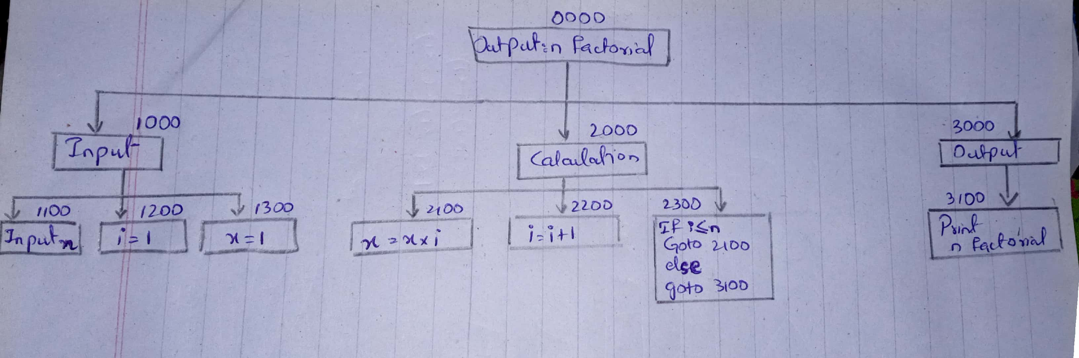

**IPO:**

|  |  |  |  |
| --- | --- | --- | --- |
| **Data** | **Process** | **Module** | **Output** |
| 1. Input n | 1. Input n | 1100 | Output: n factorial |
| 1. Declare x=1, i =1 | 1. Declare i=1 | 1200 |
|  | 1. Declare x=1 | 1300 |
|  | 1. x=x*i | 2100 |
|  | 1. i=i+1 | 2200 |
|  | 1. If i≤n Goto 2100 2. Else, Goto 3100 | 2300 |
|  | 1. Output: factorial n | 3100 |
|  | 1. Display Output | 0000 |  |

**Flowchart:**

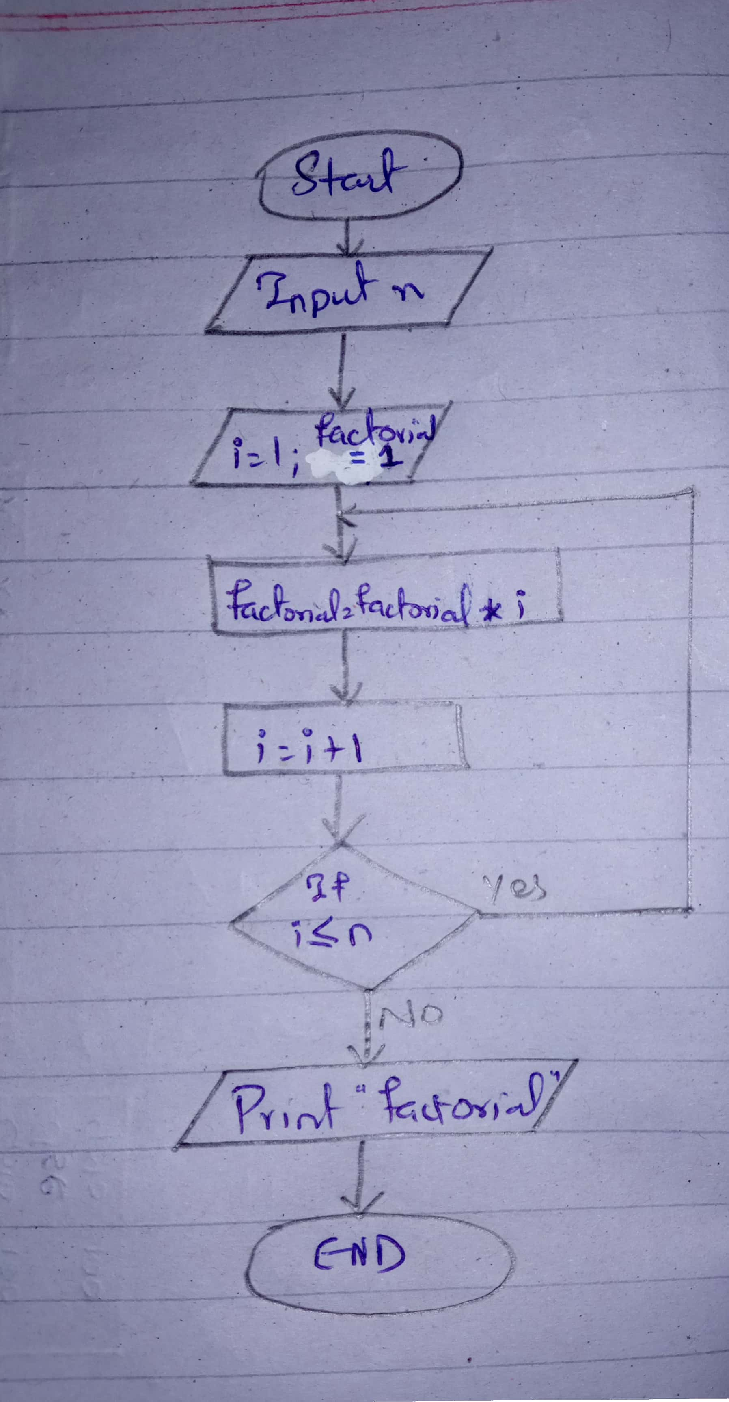

* **Find the sum of first 100 natural numbers.**

**PAC:**

|  |  |  |
| --- | --- | --- |
| **Data** | **Process** | **Output** |
| 1. Input “n” | 1. Input n | Output = Sum of first 100 natural numbers |
|  | 1. Sum = 0 |
|  | 1. Count = 1 |
|  | 1. Sum = sum + count |
|  | 1. Count = count +1 |
|  | 1. While count ≤ 100   Goto step 4 |
|  | 1. Print sum |
|  | 1. End |

**HIPO:**

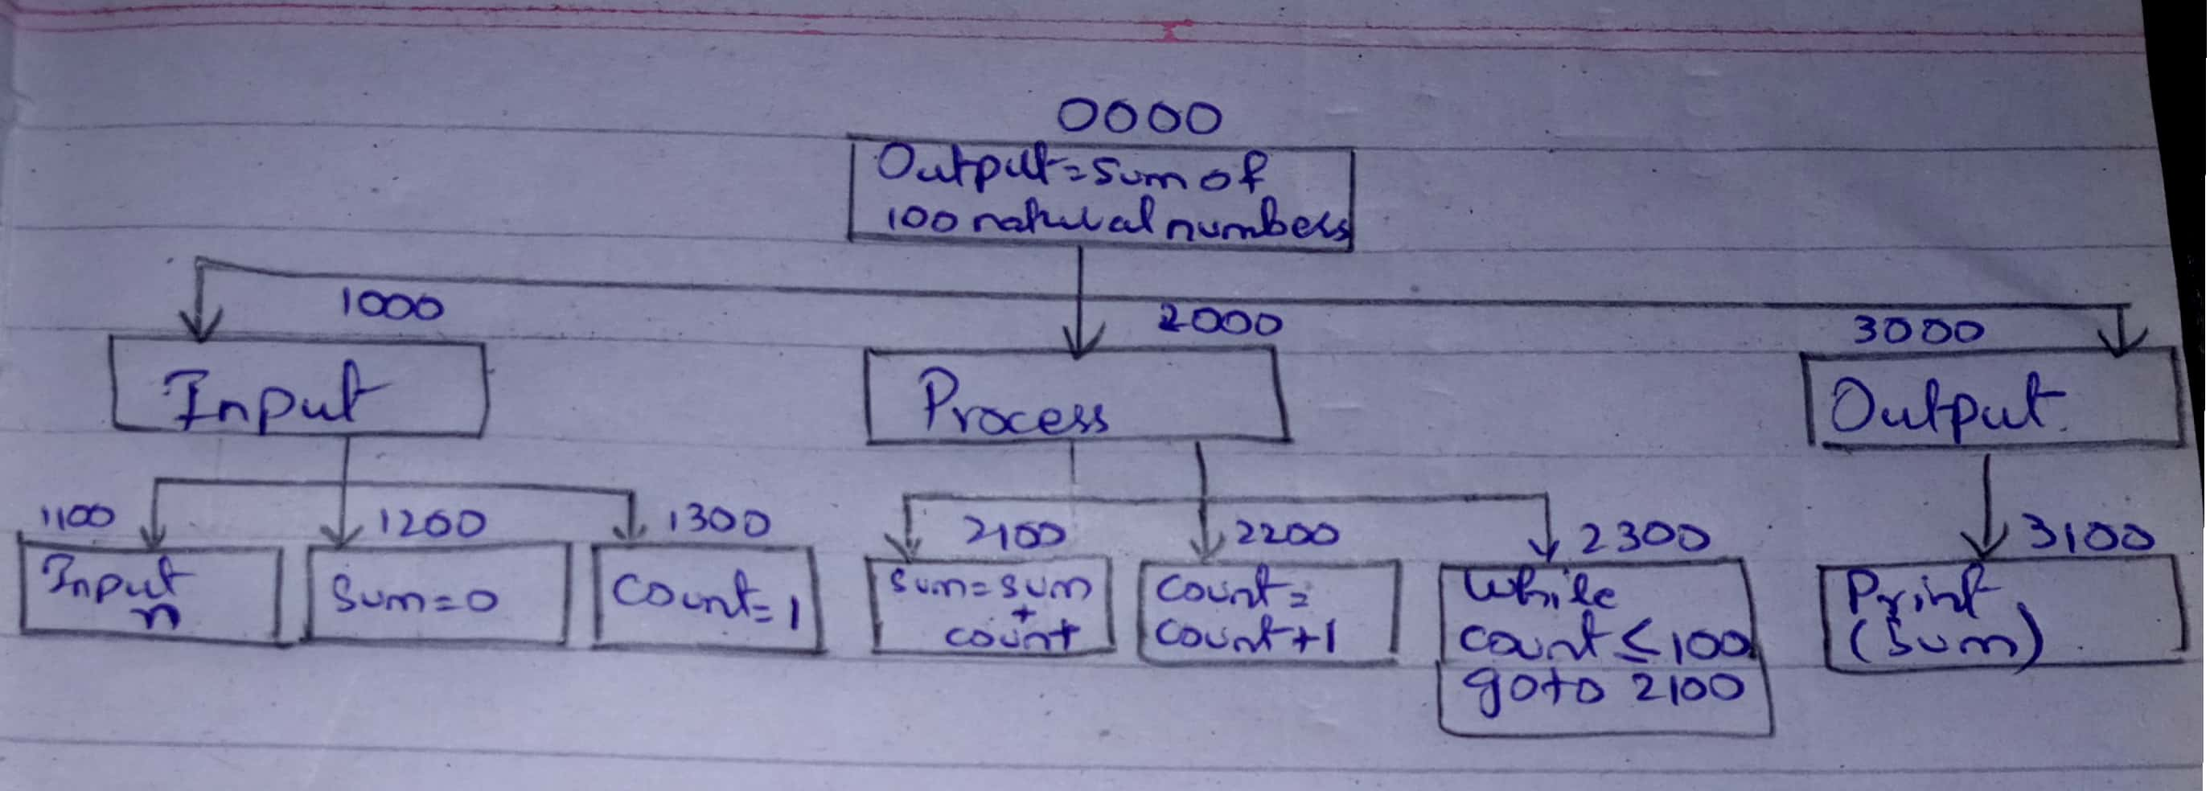

**IPO:**

|  |  |  |  |
| --- | --- | --- | --- |
| **Data** | **Process** | **Module** | **Output** |
| 1. Input n | 1. Input n | 1100 | Sum of first 100 natural numbers |
| 1. Declare sum =0 | 1. Declare sum=0 | 1200 |
| 1. Declare count =1 | 1. Declare count =1 | 1300 |
|  | 1. Sum = sum + count | 2100 |
|  | 1. Count = count +1 | 2200 |
|  | 1. While count ≤ 100 | 2300 |
|  | 1. Output: Sum of first 100 natural numbers | 3100 |
|  | 1. Display Output | 0000 |  |

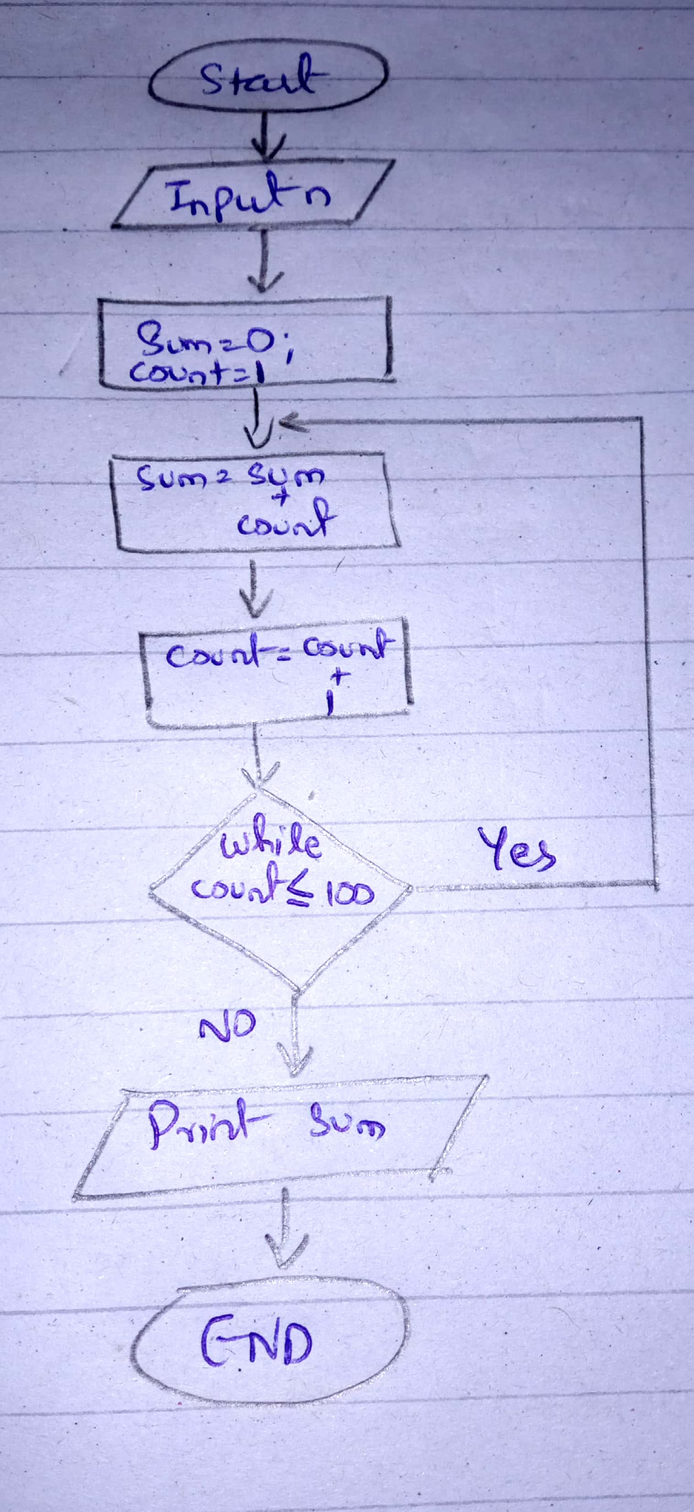**Flowchart:**

* **Find the largest of three numbers x, y and z.**

**PAC:**

|  |  |  |
| --- | --- | --- |
| **Data** | **Process** | **Output** |
| 1. Input A, B, C | 1. Input A, B, C | Output = Largest nubmer |
|  | 1. If A > B   [Then, if A>C  (A is the largest number)  Else, (C is the largest number)]  Else if B>C  (B is the largest number)  Else  (C is the largest number) |
|  | 1. End if |
|  | 1. End |

**HIPO:**

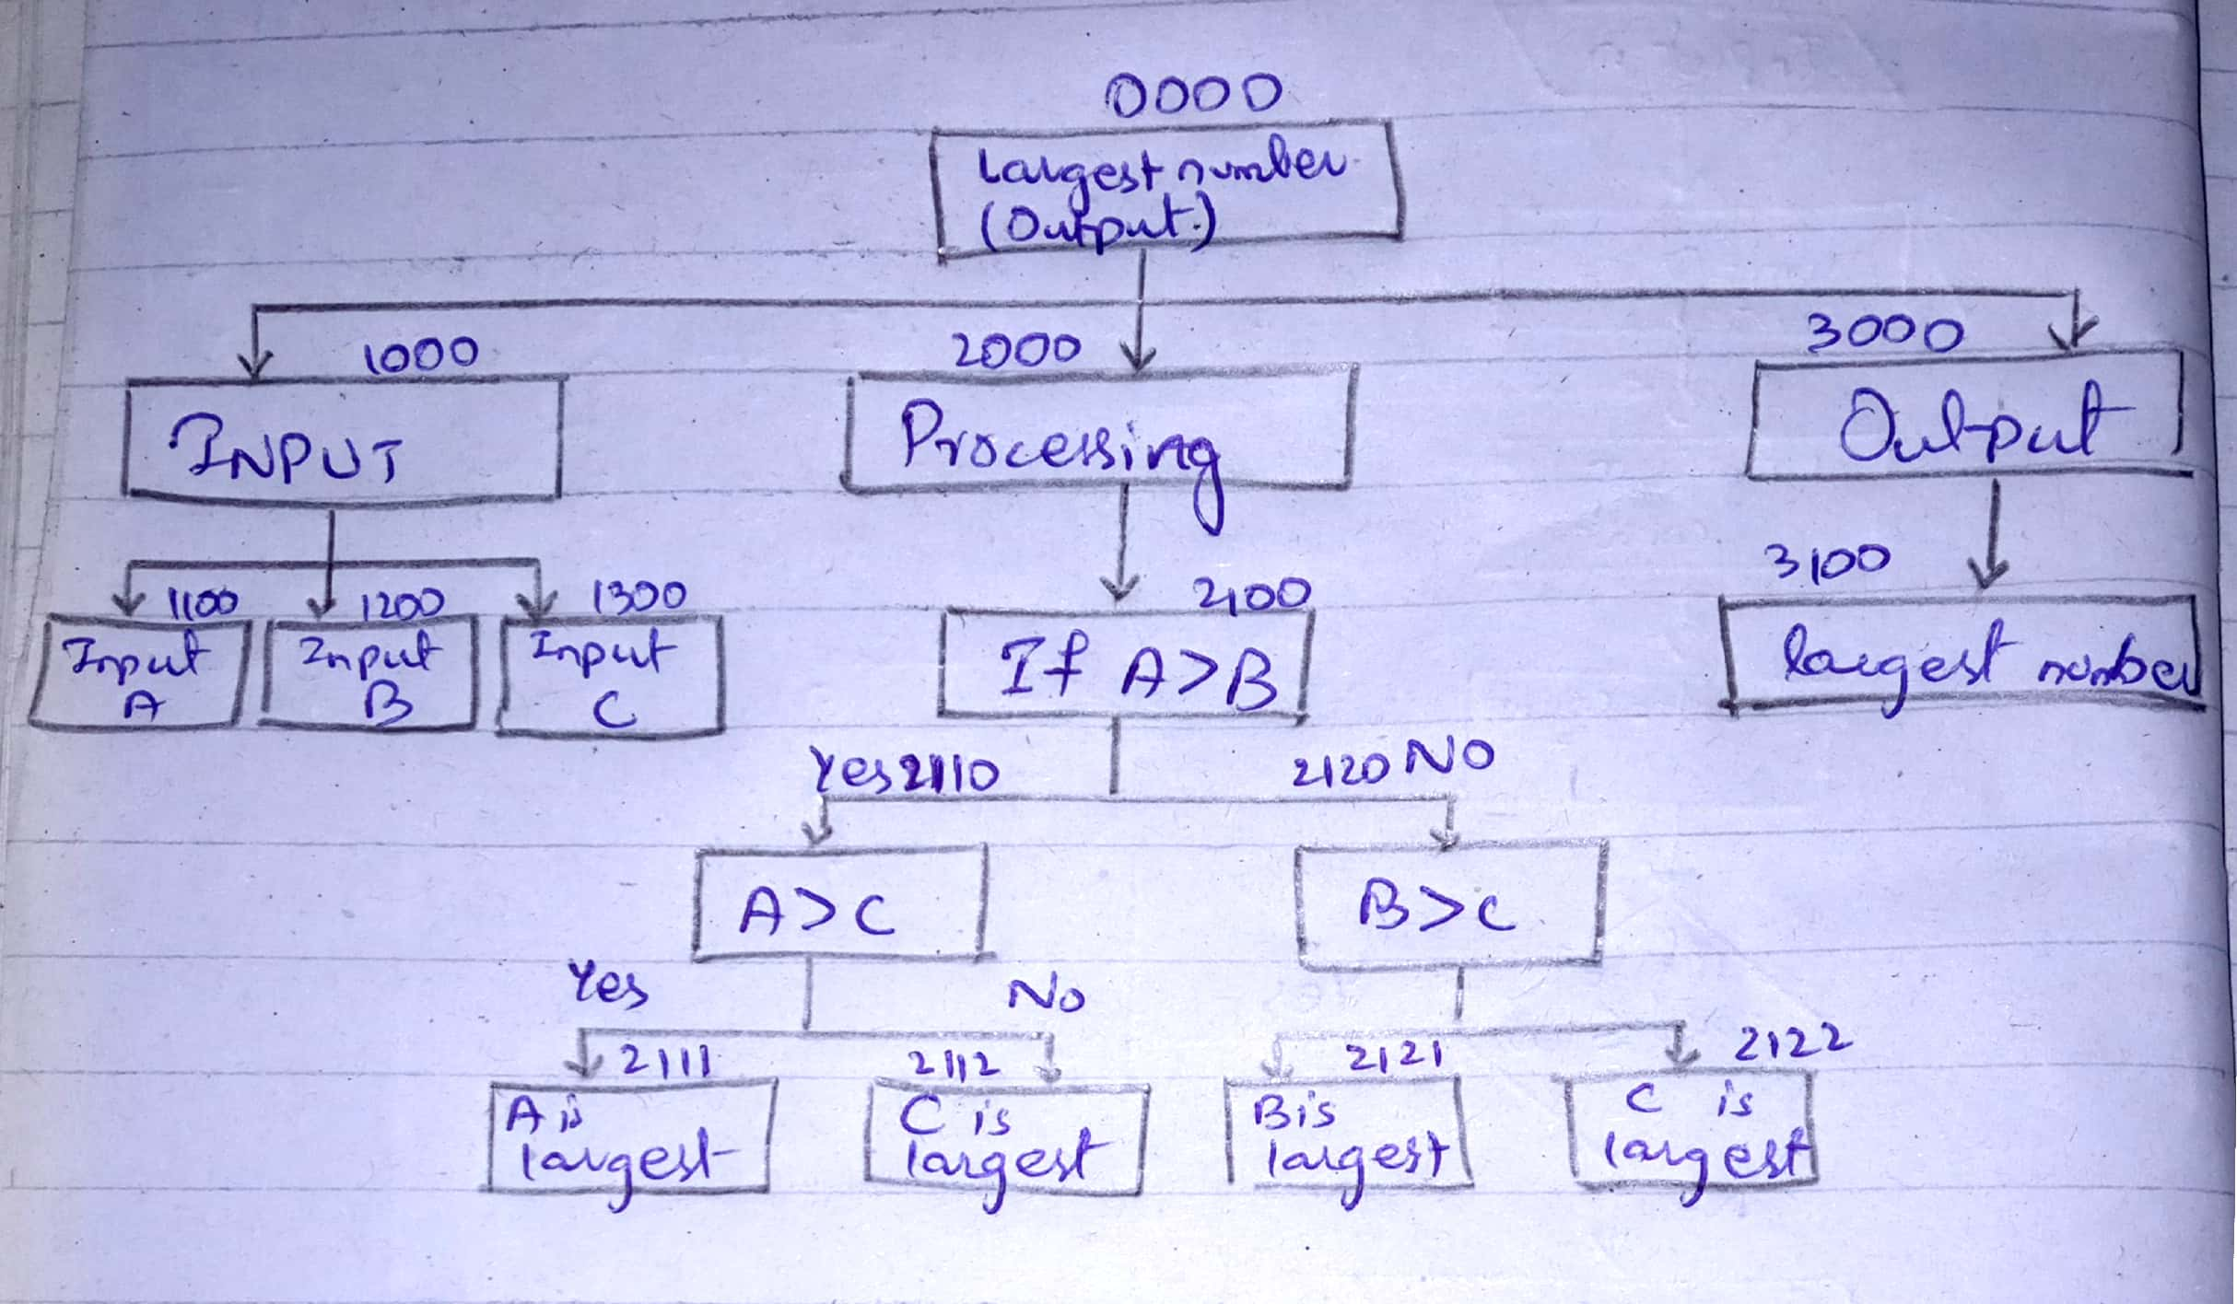

**IPO:**

**Table is on next page**

|  |  |  |  |
| --- | --- | --- | --- |
| **Data** | **Process** | **Module** | **Output** |
| 1. Input A | 1. Input A | 1100 | Print “The largest number” |
| 1. Input B | 1. Input B | 1200 |
| 1. Input C | 1. Input C | 1300 |
|  | 1. If A>B   Then, [If A>C  (A is the largest number)  Else (C is the largest number)]  Elseif, B>C  (B is the largest number)  Else, C is the largest number. | 2100  2110  2111  2112  2120  2121  2122 |
|  | 1. Print “The largest number” | 3000  3100 |
|  | 1. Display Output | 0000 |  |

**Flowchart:**

Flowchart is on next page

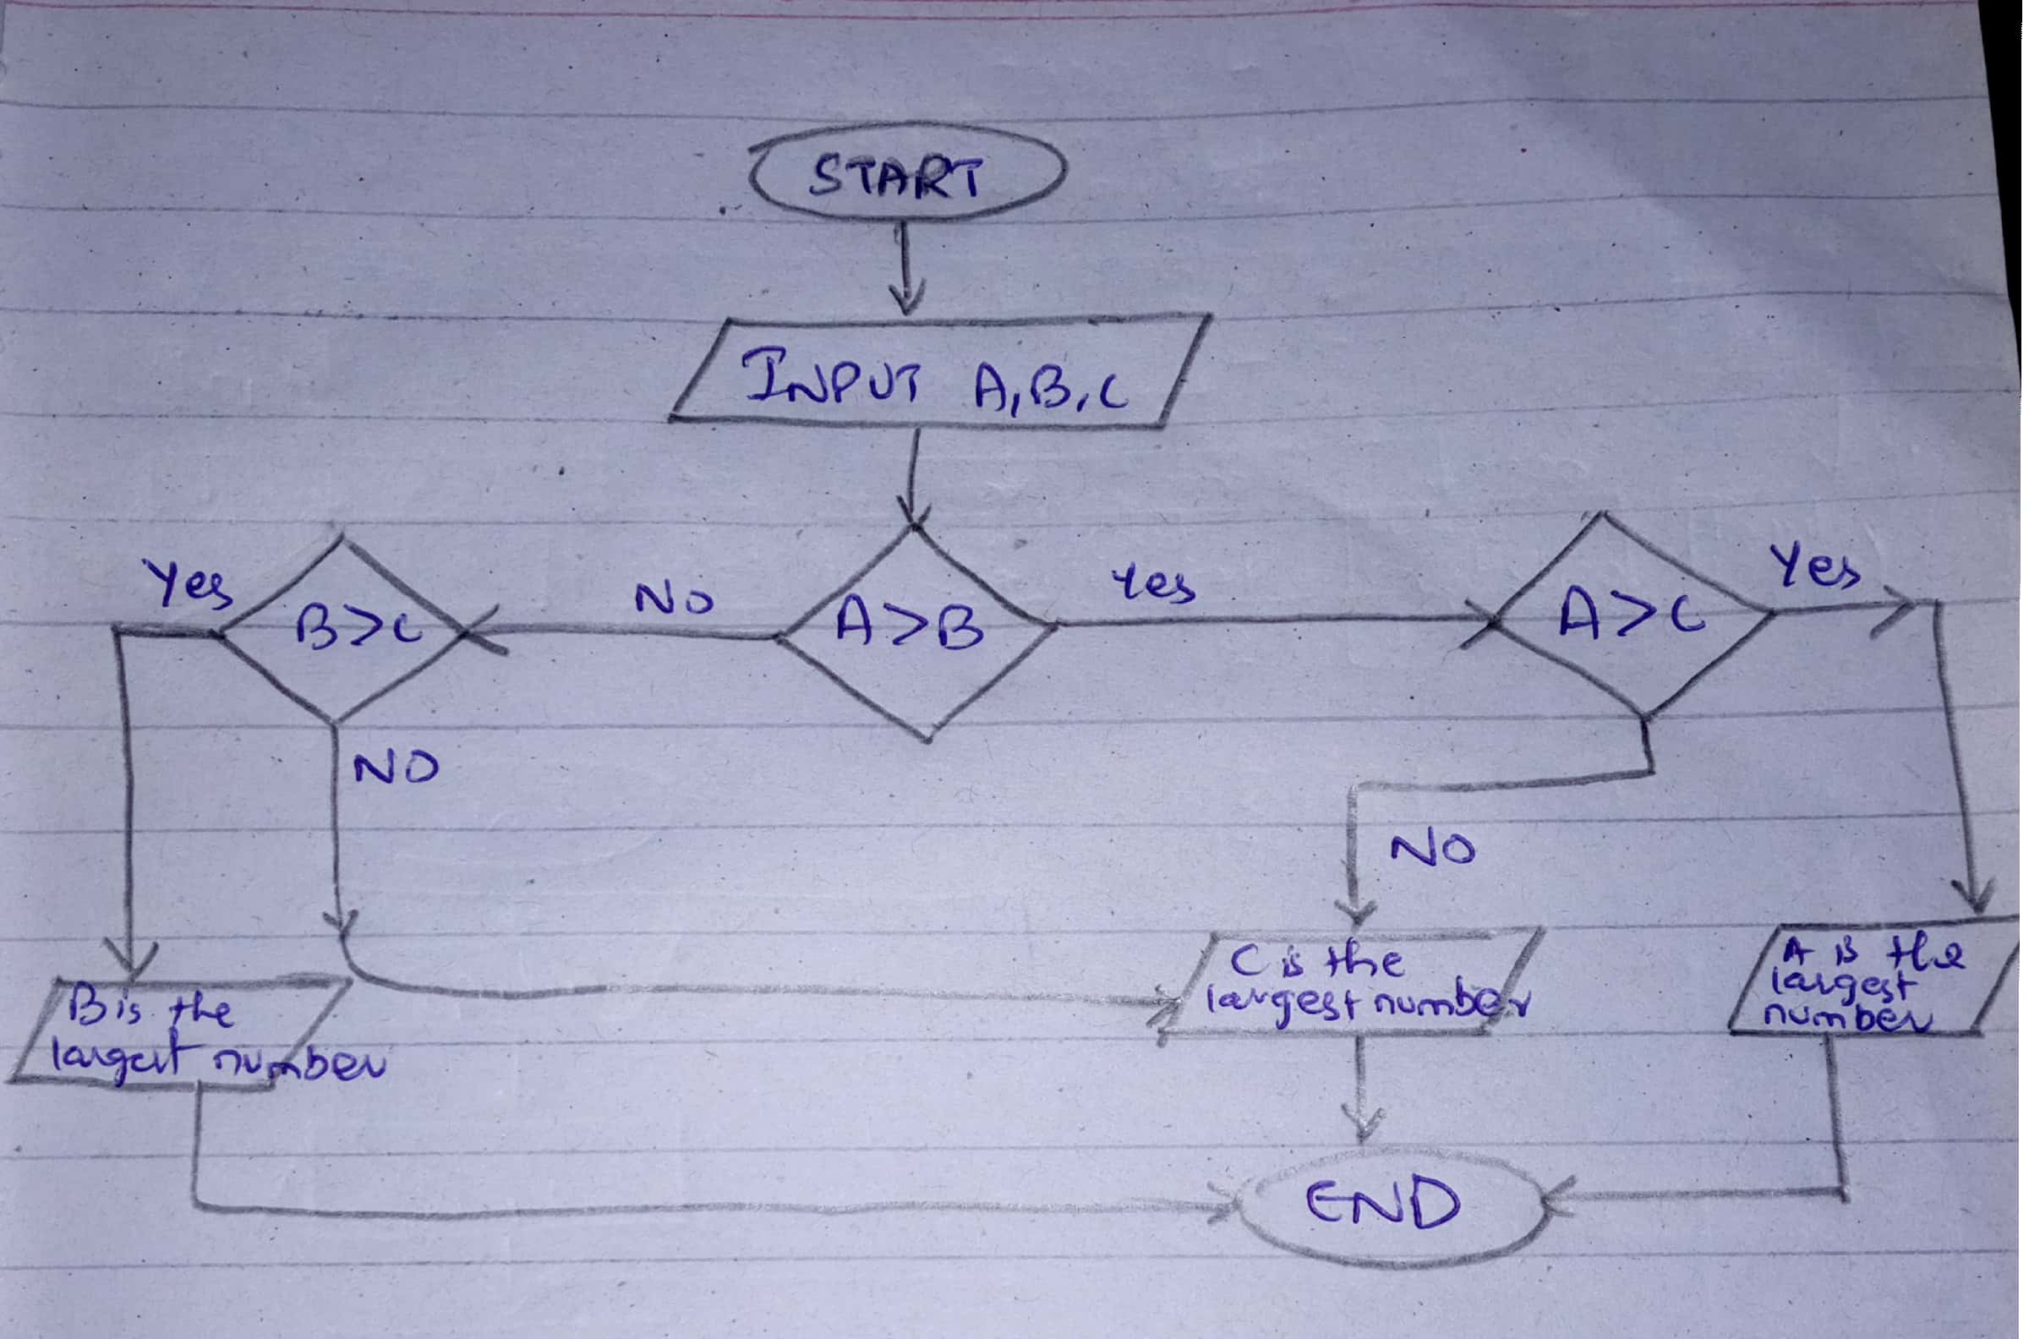

* **Determining prime number?**

**PAC:**

|  |  |  |
| --- | --- | --- |
| **Data** | **Process** | **Output** |
| Input n | Input n | Output “The number you entered is /is not a prime number” |
|  | Declare i=2 |
|  | If i = = 2  (Print “The number you entered is not a prime number). |
|  | Else if,  [If, n % i = = 0  (Print “The number you entered is not a prime number”). |
|  | Else if,  (i = i+1  If, (i < n)  Goto Step 03  Else,  Print (“The number you  entered is a prime number.”).  End if |
|  | Display Output |

**HIPO:**

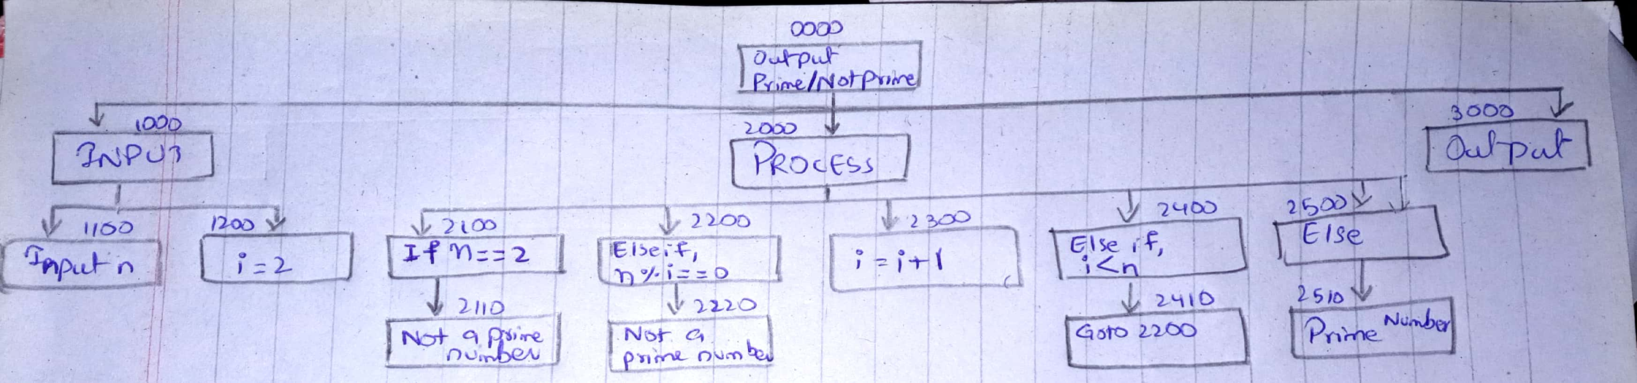

**IPO:**

|  |  |  |  |
| --- | --- | --- | --- |
| **Data** | **Process** | **Module** | **Output** |
| Input n | Input n | 1100 |  |
| i = 2 | Declare i=2 | 1200 |  |
|  | If (n==i)  Print (“Not a prime number”) | 2100  2110 |  |
|  | Else if, (n%i = = 0)  Print (Not a prime number) | 2200  2210 |  |
|  | i=i+1 | 2300 |  |
|  | Else if, (i>n)  Goto Module 2200 | 2400 |  |
|  | Else,  Print (“The number you entered is a prime number”) | 2500 |  |
|  | Output |  |  |

**Flowchart:**

Flowchart on next page

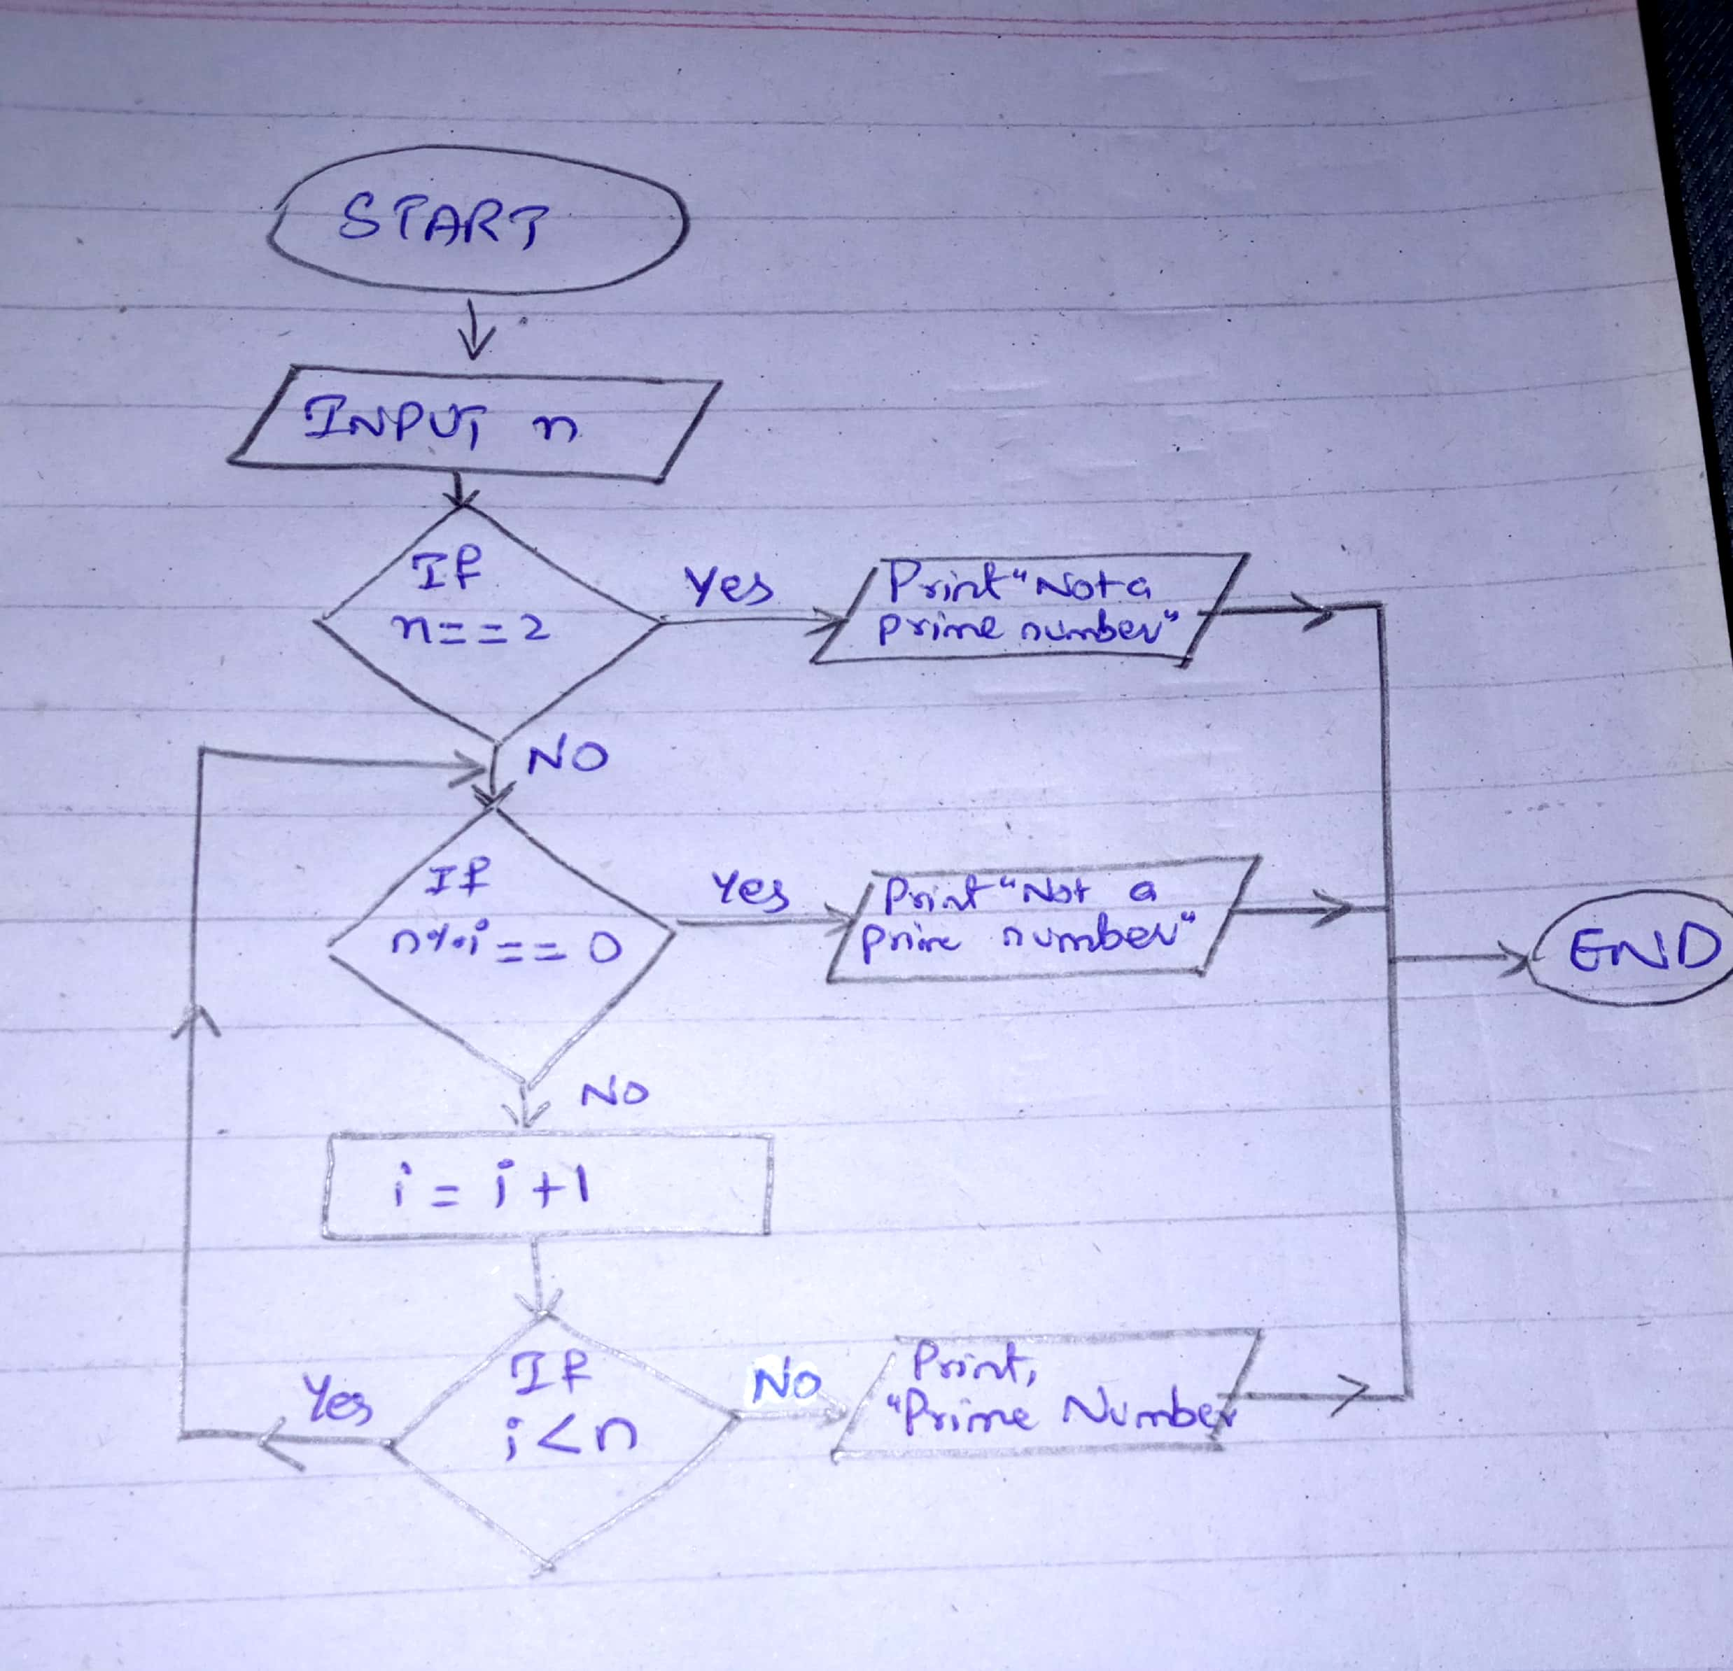

* **A program which generates first 50 items of the Fibonacci series: 1, 1, 2, 3, 5, 8,**

**PAC:**

|  |  |  |
| --- | --- | --- |
| **Data** | **Process** | **Output** |
| 1. Input n | 1. Input n | Print (Fibonacci list) |
|  | 1. Declare a=0, b=1, c=0, i=3 |  |
|  | 1. Print a, b; |  |
|  | 1. While i ≤ n 2. (c= a+b, 3. Print c, 4. a=b, 5. b=c, 6. i=i+1) |  |
|  | 1. End |  |

**HIPO:**

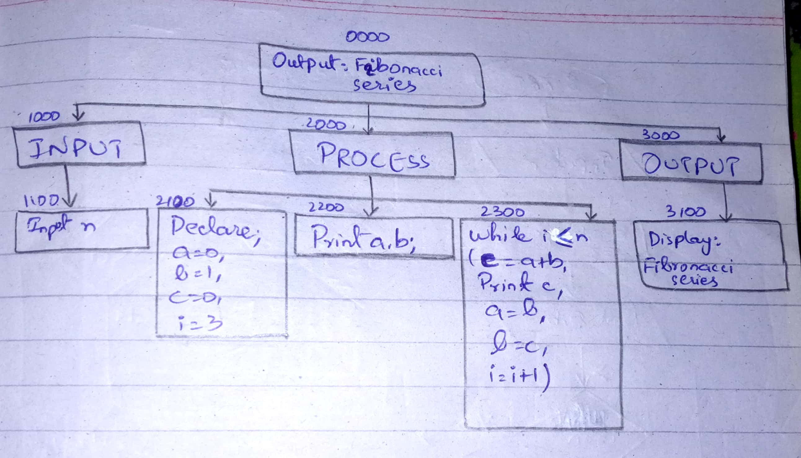

**IPO:**

|  |  |  |  |
| --- | --- | --- | --- |
| **Data** | **Process** | **Module** | **Output** |
| Input n | Input n | 1100 | Output:  Fibonacci Series |
|  | Declare  a=0, b=1,  c=0, i=3 | 2100 |
|  | Print a, b | 2200 |
|  | While i ≤ n  (c=a + b,  Print c,  a=b, b=c,  i=i+1) | 2300 |
|  | Display Fibonacci Series | 3100 |
|  |  |  |
|  |  |  |

**Flowchart:**

Flowchart is on next page

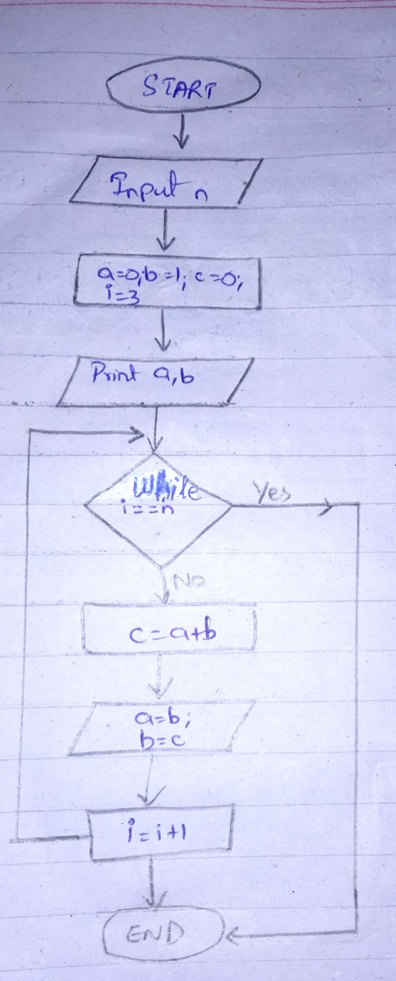

**6. Draw Flowchart of 5 problems of your own choice. But people should come up with unique problems.**

**Problem 01) Calculate the sum of two numbers input by the user**

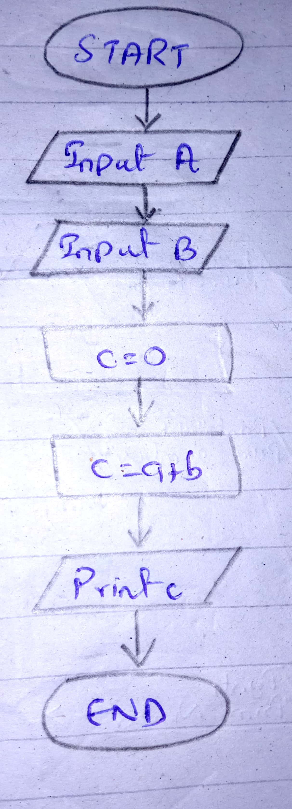

**Problem 02) Calculate the difference of two numbers input by the user**

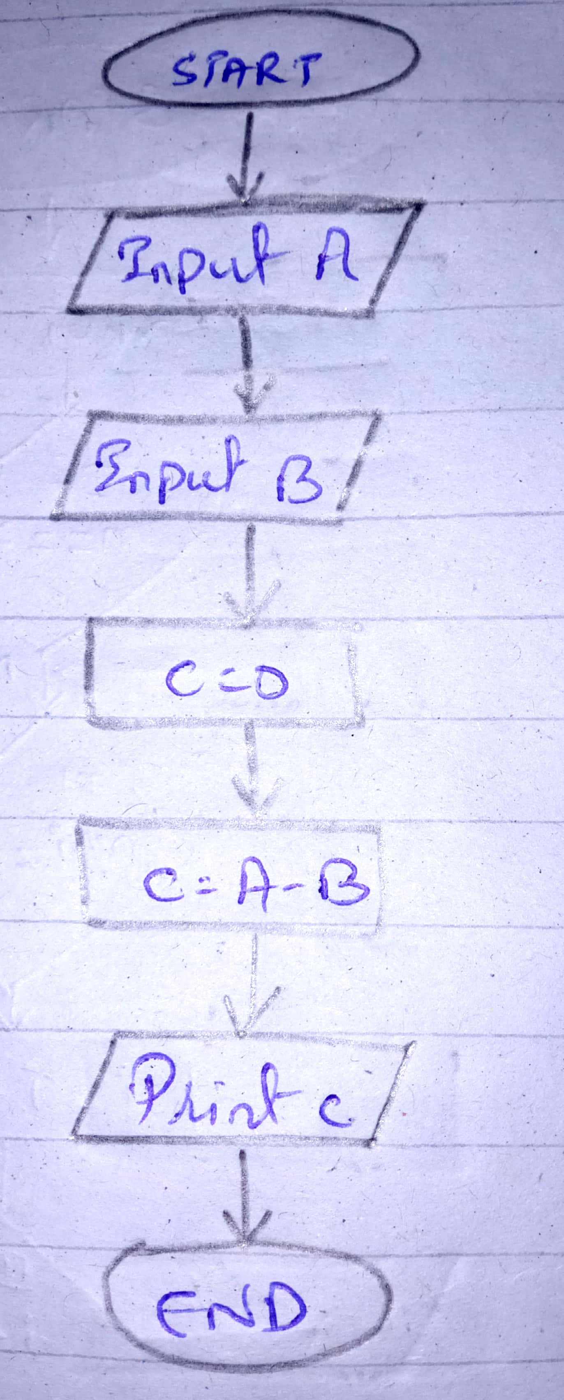

**Problem 03) Calculate the mean of two numbers input by the user**

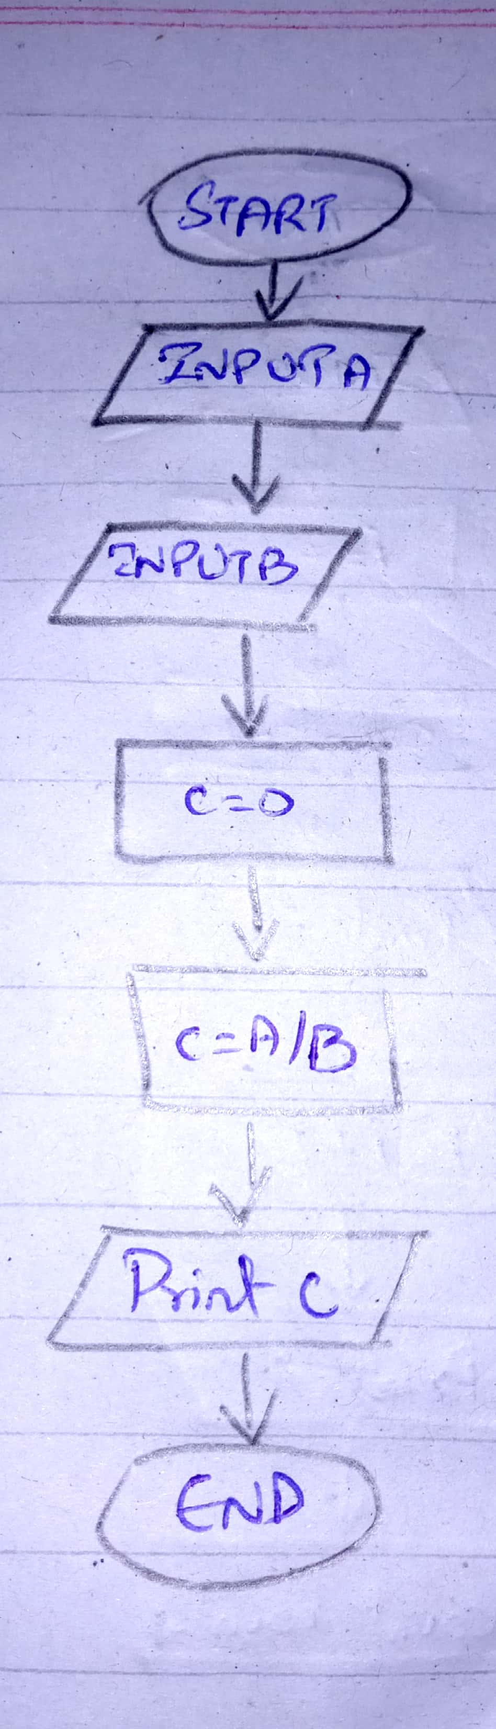

**Problem 04) Calculate the average of 5 numbers input by the user**

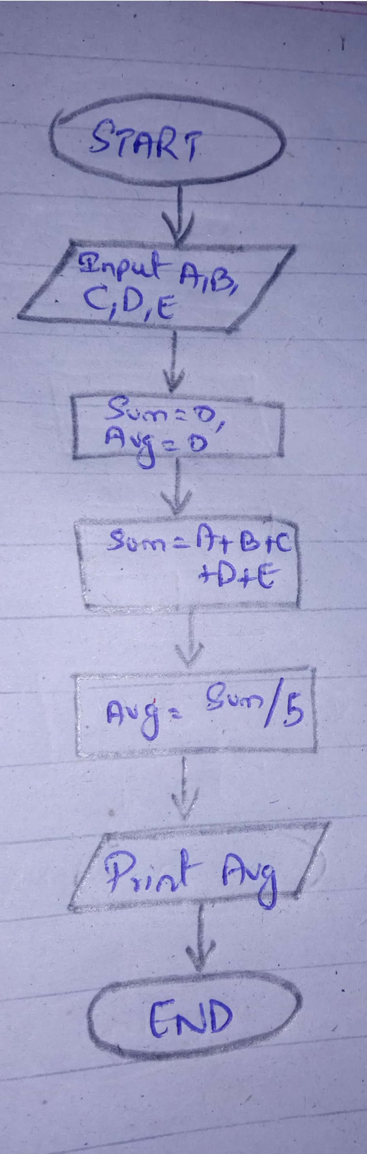

**Problem 05) Print all the even numbers upto 100**

